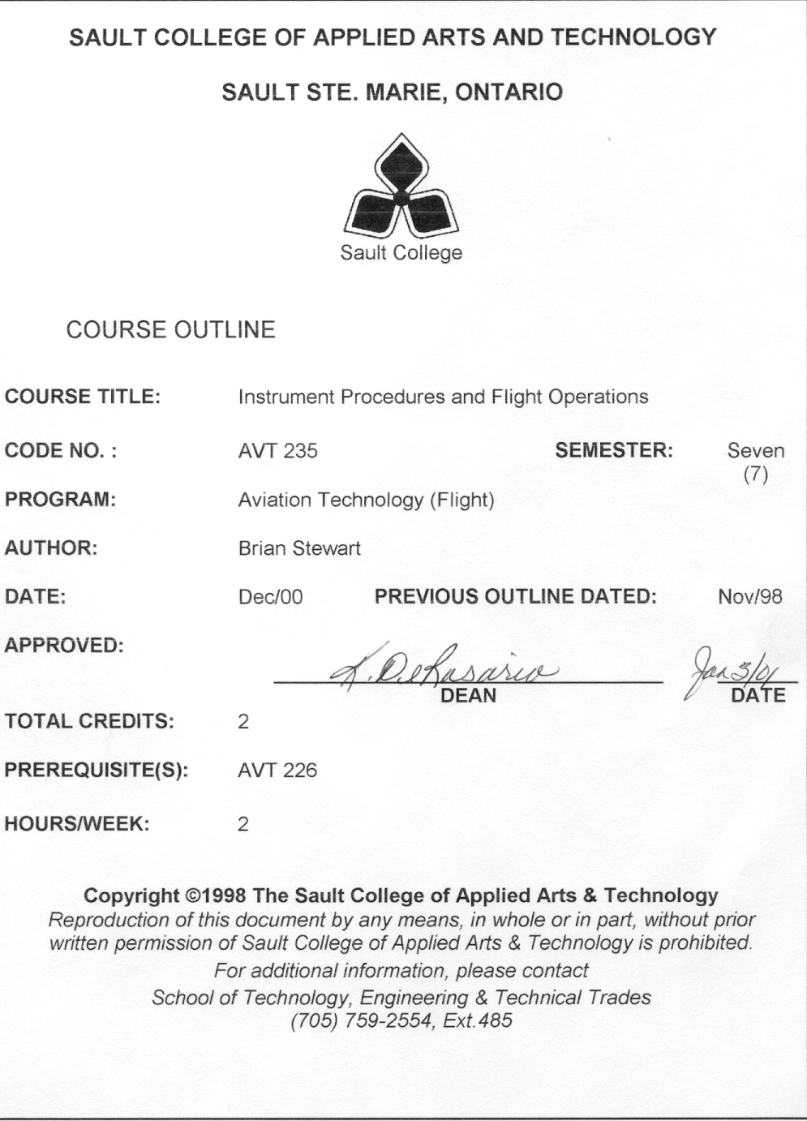
I. COURSE DESCRIPTION:
AVT 235 is designed to help you bridge the experience gap as a result of increased demand for pilots. To do this the course will use a variety of delivery techniques. There will be lectures on handling transport aircraft and their system layout, high altitude navigation as well as North Atlantic operations including extended twin-engine operations. There will be classroom instruction as well as computer labs on flight management systems. You will learn two crew procedures, learn the differences in fly by wire technology (Boeing & Airbus) as well as program and fly flight scenarios using our computer simulation lab. This course will allow you the opportunity to practice the communication/resource management /cross check skills that are being developed in AVT 280.

II. LEARNING OUTCOMES AND ELEMENTS OF THE PERFORMANCE:
Upon successful completion of this course the student will demonstrate the ability to:
- Pass Transport Canada’s Instrument Rating Exam.
Potential Elements of the Performance:
- INRAT
- Plan, program and fly a simulated flight in high level airspace
Potential Elements of the Performance:
- Proper application of the rules of the air
- Correct use of the desired track system for the trip. This could be jet airways, random routes, North American Track System, North American routes, Northern Tracks, Southern Tracks or the Organized Track System
- Program the flight management system for the desired trip
- Fly the trip using the ground-based trainer. This will include departure, enroute and approach phases as well course and approach changes in flight.
- Understand the handling characteristics of large transport aircraft and their general system layout.
- differences between light aircraft and transport aircraft – especially jet transport aircraft
- general location of systems in jet transport aircraft
- Be an important member of a flight crew.
Potential Elements of the Performance:
- two crew calls and procedures
- monitoring to trap errors
- communicate effectively with ATC, crew and operations
- utilize all resources required to have a safe and successful mission
- TOPICS:
- Instrument Flight Rules - review of general rules, departures, enroute procedures, arrival and approach procedures (preparation for the INRAT)
- High altitude and North Atlantic operations
- FMS programming
- Transport Aircraft – handling and systems
- Two crew operations
- REQUIRED RESOURCES/TEXTS/MATERIALS:
Instrument Procedures Manual
A.I.P.
Jeppeson Computer
Enroute Low Altitude - LO 3&4
Canada Air Pilot - CAP 4
Terminal Area Charts
Canada Flight Supplement

VI. EVALUATION PROCESS/GRADING SYSTEM
- The student will be assessed by tests.
- Term tests | 50%
- Final Exam | 50%

The following semester grades will be assigned to students in post secondary courses:

Grade | Definition | Grade Point Equivalent
A+ | 93-100% | 4.0
A | 87-92% | 3.75
B | 80-86% | 3.0
C | 70-79% | 2.0
R | Below 70% | 0.0

 | CR (Credit) | Credit for diploma requirements has been awarded.
 | S | Satisfactory achievement in field placement or non-graded subject areas.
 | U | Unsatisfactory achievement in field placement or non-graded subject areas.
 | X | A temporary grade. This is used in limited situations with extenuating circumstances giving a student additional time to complete the requirements for a course (see Policies & Procedures Manual – Deferred Grades and Make-up).
 | NR | Grade not reported to Registrar's office. This is used to facilitate transcript preparation when, for extenuating circumstances, it has not been possible for the faculty member to report grades.

- Students may request a deferment of a test for compassionate reasons. Compassionate Grounds for deferment will include but not be limited to death of an immediate family member, personal illness, or recent diagnosis of a serious illness of a family member. Rewrites will not be permitted after the fact for compassionate reasons.
- “R” grades in any subject at the end of a semester will result in termination from the program. Re-writes in aviation subjects are not permitted except as provided in the re-write policy below.
- Attendance is mandatory for all Aviation classes unless approval is granted in advance.
- Although attitude, co-operation, etc., are not graded, students may be terminated based on their performance in this area. These attributes are also considered in the selection of the Air Canada Award and other scholarships.
- Dates of tests will be announced at least 1 week in advance.

RE-WRITE POLICY
- No re-writes on term tests.
- The qualifier exam (for INRAT) of AVT 235 may be re-written in the event of a failure provided the semester average from semester six (6) is 70% or greater and the failed qualifier exam is within 5% of a pass. (i.e. 65% or above). The re-written qualifier exam will be averaged with the failed qualifier exam to determine the resulting mark, which must be 70%, or above to be recommended to write the INRAT.
- In the event of a failure the final exam of AVT 235 may be re-written provided the semester average is 70% or greater and the failed final exam is within 5% of a pass. (i.e. 65% or above). The re-written final exam will be averaged with the failed final exam to determine the resulting mark which must be 70% or above to pass.

VII. | SPECIAL NOTES:
Special Needs:
If you are a student with special needs (e.g. physical limitations, visual impairments, hearing impairments, or learning disabilities), you are encouraged to discuss required accommodations with your instructor and/or the Special Needs office. Visit Room E1204 or call Extension 493, 717, or 491 so that support services can be arranged for you.

Retention of course outlines:
It is the responsibility of the student to retain all course outlines for possible future use in acquiring advanced standing at other post secondary institutions.

Plagiarism:
Students should refer to the definition of “academic dishonesty” in Student Rights and Responsibilities. Students who engage in “academic dishonesty” will receive an automatic failure for that submission and/or such other penalty, up to and including expulsion from the course/program, as may be decided by the professor/dean. In order to protect students from inadvertent plagiarism, to protect the copyright of the material referenced, and to credit the author of the material, it is the policy of the department to employ a documentation format for referencing source material.

Course outline amendments:
The Professor reserves the right to change the information contained in this course outline depending on the needs of the learner and the availability of resources.

VIII. | PRIOR LEARNING ASSESSMENT:
 | Students who wish to apply for advanced credit in the course should consult the professor. Credit for prior learning will be given upon successful completion of a challenge exam or portfolio.
IX. | DIRECT CREDIT TRANSFERS:  Students who wish to apply for direct credit transfer (advanced standing) should obtain a direct credit transfer form from the Dean’s secretary. Students will be required to provide a transcript and course outline related to the course in question.

